Employee Time Entry – Negative Duration Quick Reference Guide
Last Updated: 11/13/2023
Employees assigned the Negative Duration time entry profile are only required to edit their time sheet if they work more (overtime), different (flex time), or costing exception (cost override) hours than their regular schedule indicates (example: Overtime).
- If you worked fewer hours than your regular schedule indicates for a week, submit a Time Off request to cover the missing hours.
- If flexing time, a comment may be entered or an emailed agreement between the employee and supervisor can be used. The hours on the timesheet should not be adjusted.

Exception entries must be entered directly following your last shift of each week. When an exception entry is saved, it flows to your supervisor for approval.

Contents
Responsibilities 1
Employee Responsibilities 1
Supervisor Responsibilities 1
Overtime 2
Timekeeping in SuccessFactors 2
Accessing SuccessFactors 2
Accessing the Timesheet 2
Cost Overrides 3
Entering Overtime 4
Entering Flex Time 4
Amending Timesheet After Saving 5

Responsibilities

Employee Responsibilities
- Accurately recording time worked
- Selecting the appropriate job when recording time (if employee records time for multiple jobs)
- Proactively working with their supervisor to resolve issues as needed
- Ensuring that their time is recorded completely and accurately and submitted for supervisor approval following their final work day of each week.
- Remember: The time entered into the system will be considered true and accurate as of the end of an employee’s pay period. It is the employee’s responsibility to review their time often (at least at the end of each shift and at the end of the pay period) to make sure the recorded hours are true and correct; and to review and confirm the accuracy of any changes that a supervisor makes to time entries.

Supervisor Responsibilities
- Proactively working with their employees to resolve issues as needed
- Reviewing/approving all time sheets for all of their employees by 10:00 am on the Monday following the end of each pay period
- Proactively working with their business office to update employee work schedules and report costing exceptions for their employees’ time worked
- Remember: The time entered into the system will be considered true and accurate as of the end of an employee’s pay period. It is the employee’s responsibility to review their time often (at least at the end of each shift and at the end of the pay period) to make sure the recorded hours are true and correct and to review and confirm the accuracy of any changes that a supervisor makes to time entries.

Overtime
SuccessFactors adheres to the University policy regarding overtime. When a full-time employee records over 40 hours in a workweek, the time will be designated as overtime. “Hours worked” in a work week will consist only of hours actually worked. (Exception: Worker’s Compensation, University Holidays).
Overtime for employees with multiple positions will be charged to each position based on the ratio of hours worked across the employee’s positions for that week.

Timekeeping in SuccessFactors

Accessing SuccessFactors
Access the Employee Launchpad SuccessFactors.  Log in using Username and Password. |  | https://one.purdue.edu/  

Accessing the Timesheet
If you hold multiple positions, use the Change Selected Employment menu to select the position for which you would like to record time | 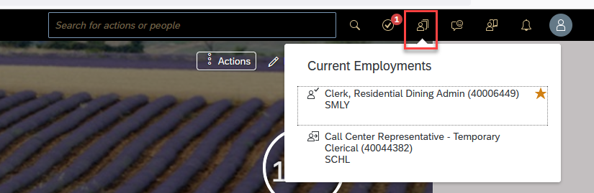
If you hold multiple positions and they are similarly named, click My Profile to validate that the correct position has been selected | 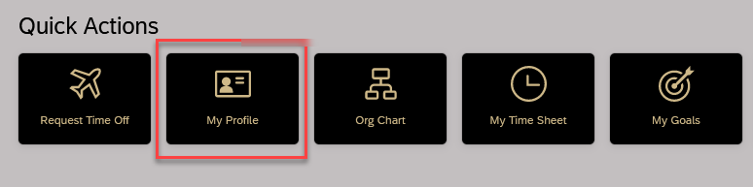
If you hold multiple positions and they are similarly named, click the Employment Information tab to view the details of the position selected in order to ensure time is recorded for the correct position. | 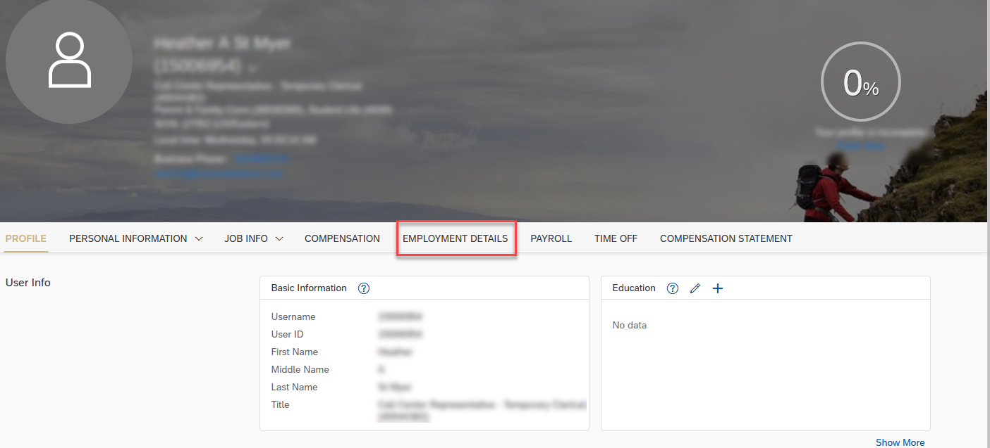
(If you completed the previous steps to verify multiple positions, return to the SuccessFactors home page and select the desired position).  Click the My Time Sheet tile. | 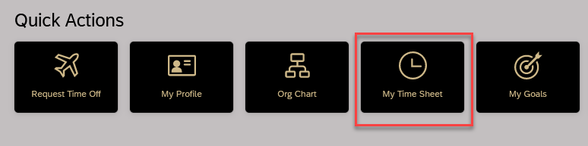
The current week’s timesheet opens. The current day is highlighted. Hours for Negative Time Entry employees are auto-filled at the beginning of each work day.

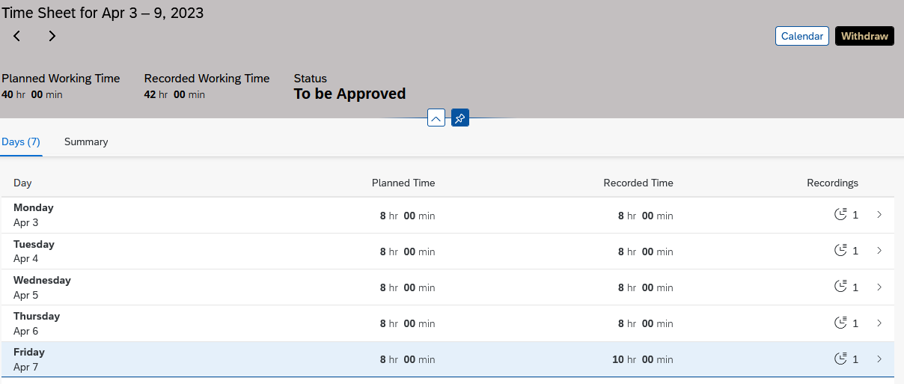

Cost Overrides
Select the day on which the Cost Override is to be entered.  Within Working Time click the Record to edit the Cost Override Section.  Click the List Icon and click to select your account.  Click Ok.  Click Save. |  |  | 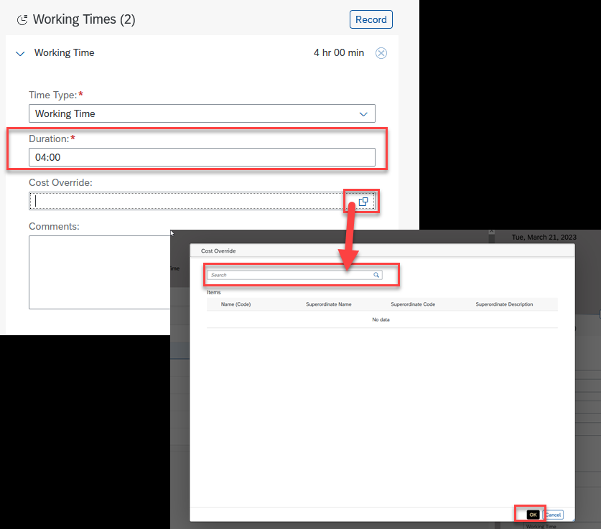

Entering Overtime
- Select the day on which additional hours are to be added.
- To enter additional time to scheduled work hours, click Record and enter the total amount of time worked that day into a blank line of Working Time. This will void the original line of Working Time.
  - Ex. Worked 10 hours instead of the scheduled 8.
- Click Save.
- An acknowledgement message will appear shortly after.
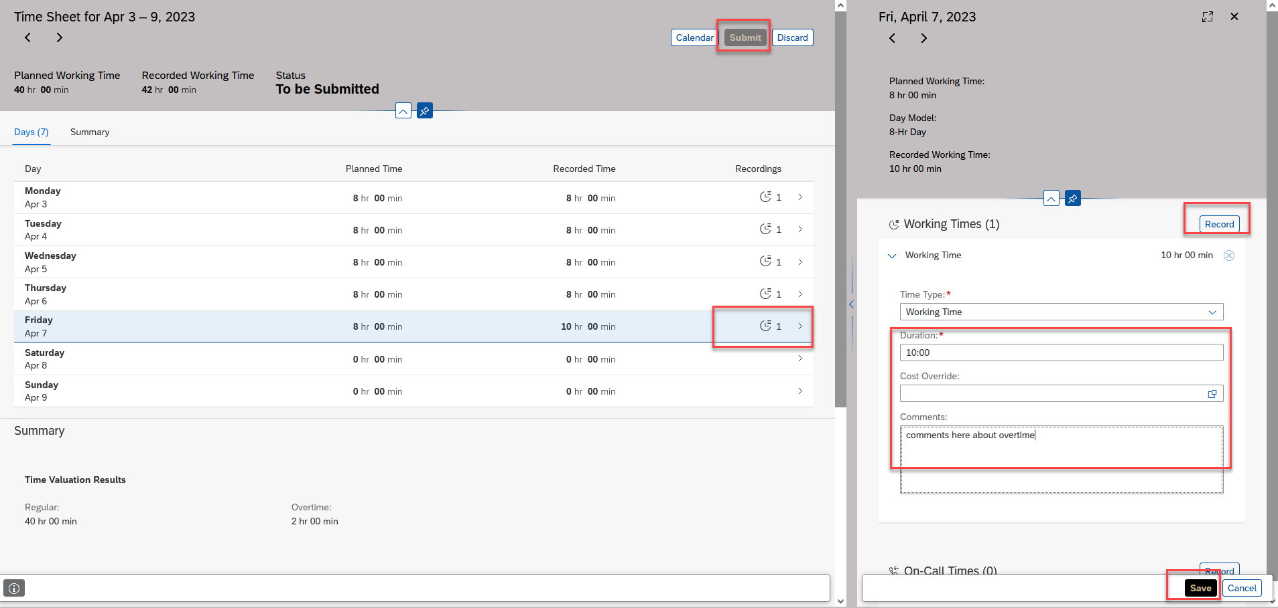
Status remains “To be Submitted” until Sunday evening. |  |  |  | 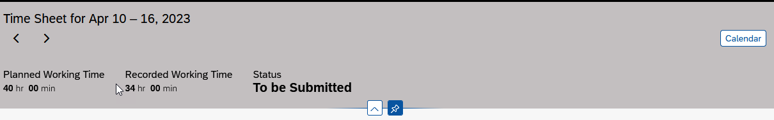

Entering Flex Time
You can add notes to Time Sheet or document your approved flex arrangement via email with your supervisor.
When adding a note to the Time Sheet:
- Select the day on which Flex Time is to be noted.
- Click Record
- Copy the scheduled number of Working Time hours into the new Duration line
- Locate the comment box and type the flex arrangement. It is only necessary to add a comment to one of the days involved in each flex time situation.
- Click Save.
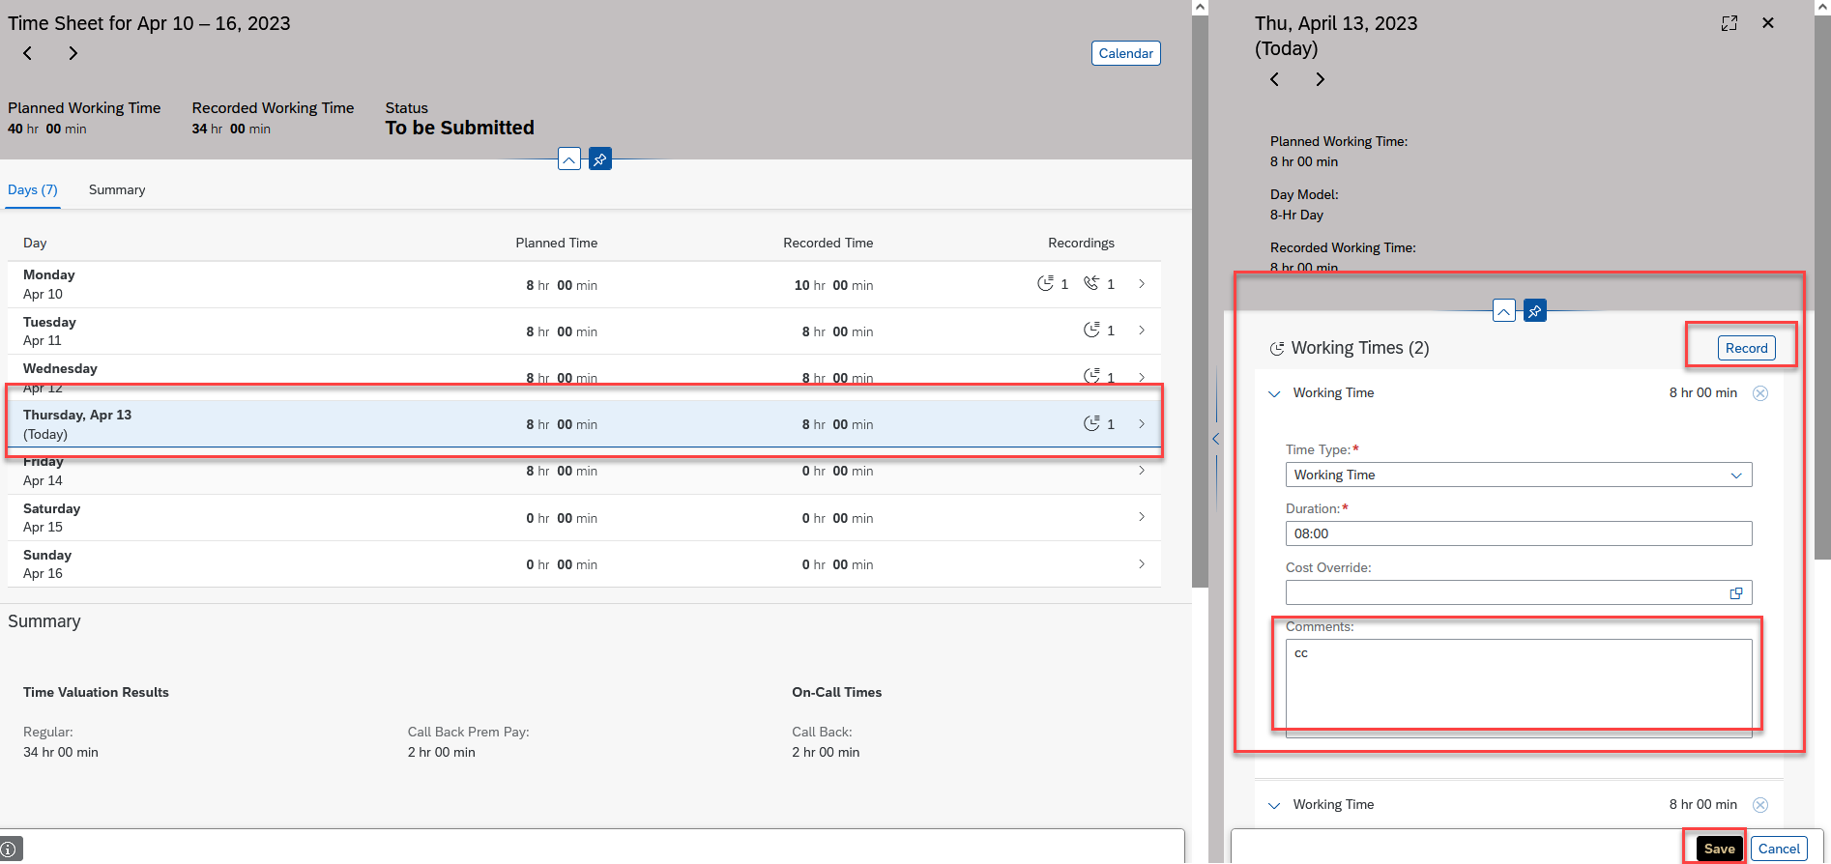

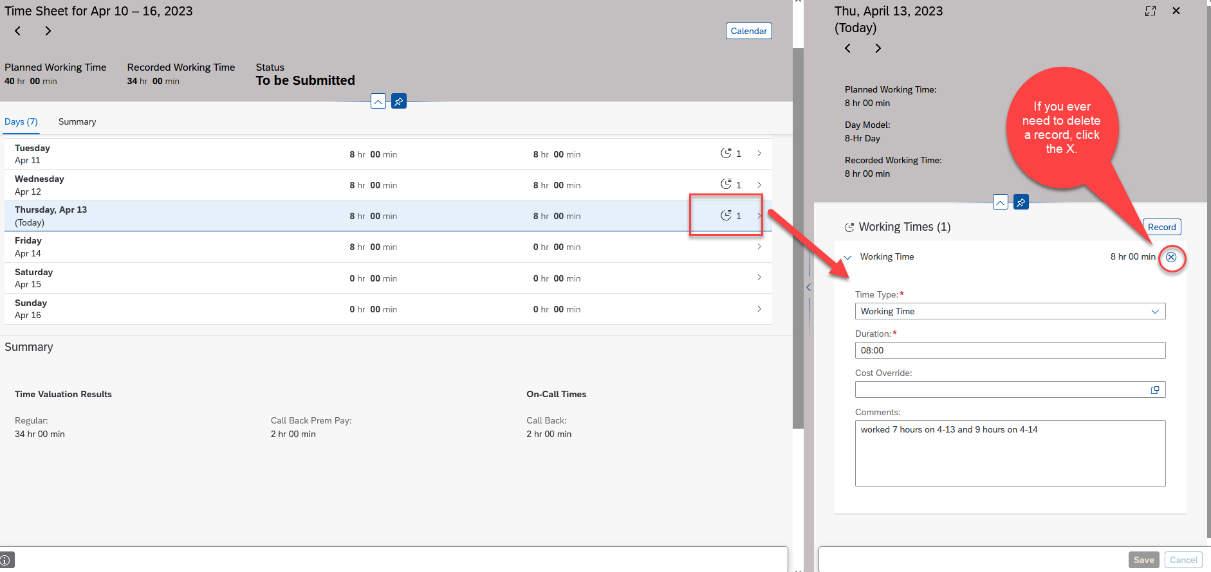
Note: When flexing, do not adjust the hours on each day to reflect exact hours worked. Since flexing results in the same total hours for the week, there is no need to adjust daily. Additionally, adjusting the hours daily will trigger a notification to your supervisor. Reports can be run on comments recorded in case of a need for a flex-time audit.

Flex Time entries only flow for supervisor approval if the flex time entry requires editing a previously approved timesheet.

Amending Timesheet After Saving
Employees are able to edit timesheets (even if already approved) that are within the current or two previous pay periods. After a timesheet is edited, it flows to the supervisor for approval.
Please note:
- If the timesheet has already been approved by the supervisor, locate the timesheet to be changed (using the directional arrows to locate the correct timesheet). Click withdraw and edit accordingly.
- If the timesheet has NOT already been approved by the supervisor, locate the timesheet to be changed (using the directional arrows to locate the correct timesheet). There will not be a Submit button, the changed timesheet will auto-submit overnight.
Locate the Timesheet to be changed (use the directional week arrows or calendar)
Click Withdraw (if the timesheet has already been approved by supervisor)
- Make desired changes to the Time Sheet by selecting the day, clicking Record and typing the correct hours in Duration.
- Click Save.
- Click Submit. (If the timesheet has not been approved by supervisor yet, there will be no Submit button. It will auto submit overnight.)

Enter any comments.  Click Submit.  Your manager will receive notification of request for approval. |  |  |  | 